
2024-25

School of Physics, Engineering and Computer Science

PROJECT HANDBOOK
BSc Computer Science Project

2nd December 2024
Version 1.1
CONTENTS

1 Introduction 1
1.1 Individual Project Module Codes 1
1.2 Project Module Stages 1
2 Project Selection Process 2
2.1 Project Selection Resources 2
2.2 Project Selection Timetable 2
2.2.1 Induction Week 2
2.2.2 First Teaching Week 2
3 Supervision and Assessment 4
3.1 Project Supervisors 4
3.2 Second Marker 4
3.3 Third Marker 4
3.4 Assignments 4
3.4.1 Continuous Progress Review 5
3.4.2 Project Outline 6
3.4.3 Project Report 7
3.4.4 Viva 7
4 Project Work 8
4.1 Backing up work 8
4.2 Planning Your Project 8
4.3 Project Logbook 8
4.4 Testing 10
4.5 Academic Misconduct 10
4.5.1 Plagiarism 10
4.5.2 Self-Plagiarism 11
4.5.3 Collusion 11
4.5.4 Contract Cheating 11
4.5.5 Falsification of Data 12
4.5.6 Ethics Misconduct 12
4.6 Personal Difficulties 13
4.7 Referral Assignments 13
5 Project Selection 14
5.1 Identifying a Project Problem 14
5.2 Formalising your Project Problem 14
6 Project Outline 15
7 Continuous Progress Review 16
7.1 Grading Criteria 16
8 Project Report 18
8.1 Writing Style 18
8.2 Report Format 18
8.3 Report Presentation and Layout 21
8.4 Diagrams, Drawings, Photographs and Parts Lists 21
8.5 Software 22
8.6 Final Report Check List 22
9 Viva 24
9.1 Organisation and Structure 24
9.1.1 Organisation 24
9.1.2 Structure 24
9.2 Purpose 25
9.2.1 Academic 25
9.2.2 Administrative 25
9.3 Submission 26
10 General Advice for your Project 27
10.1 General Recommendations 27
10.2 Marking Guidelines 27
10.3 Common Pitfalls and Misconceptions 28
APPENDIX A: Marking Schemes 32
APPENDIX B: Project Selection Form 34
APPENDIX C: Project Resources Checklist 37
APPENDIX D: Risk Register 38
APPENDIX E: Ethics Checklist 39
APPENDIX F: Project Management Review 40

- Glossary

Supervisor: | Each student is allocated a Project Supervisor who guides and advises them throughout the project period. The Supervisor plays the major role in the marking of all assessments on the project.
Second Marker: | The Second Marker acts as the internal moderator for the project. They mark some assessments independently of the supervisor.
Project Coordinator: | The Project Coordinator has overall responsibility for the administration of all final year projects. The coordinator has the job of overseeing the project selection and allocation process and ensuring that materials placed on the school’s learning resource platform (CANVAS) are kept up to date. They can be contacted via the details provided on the BSc CSIT Final Year Projects site
Module Leader(s): | There is a set of five separate modules that cover all final year projects on the BSc Computer Science Programme. Each has a Module Leader responsible for the administration of the individual modules and the presentation of grades at the Exam Board. They can be contacted via the details provided on the BSc CSIT Final Year Projects site and the individual project module CANVAS sites.
Intellectual Property: | During your project, you may be exposed to confidential information that belongs to the University or to a third-party organisation in the case of industrial/commercial linked or sponsored projects.  You may also create new intellectual property (IP), either on your own or jointly with a third-party organisation. This IP may include copyright works (such as computer software) or an invention (which could be patented). It is important that UH can reassure the third-party organisation that its confidential information will be respected.  It is also important that agreement is reached before the project starts regarding the ownership of any new IP that is created, and the circumstances in which other parties can use this IP. In some cases, any new IP will be owned by the third-party organisation, for example where they are funding a project and expect to receive a benefit in return. In other cases, you will retain ownership of any new IP that you create. In all such cases, in order that the terms of your project are clear to everyone involved, you will be asked to sign a legal agreement before the project starts, covering confidentiality, intellectual property, and other related issues. You will of course have an opportunity to ask questions about the agreement you are asked to sign, and to take advice on it.

Introduction
This handbook describes all aspects of the Individual Final Year Project on the BSc Computer Science Programme. Please read the information completely to identify your responsibilities and the deadlines you need to respond to.
The project is a demanding and challenging, yet rewarding, part of the degree programme. It is worth 30 credits, running across semesters A and B. It will require 300 hours of your time to complete successfully.
The project module CANNOT be compensated and must be passed in order toto be awarded the relevant degree. Referrals can be awarded, in such cases, specific conditions will be identified and communicated to the student, providing an opportunity to achieve a pass grade.
The specific aims and learning outcomes for the project module are described in the Definitive Module Documents (DMD), posted on the relevant project module Canvas website.
Two key points to note from the outset:
- Be PROACTIVE regarding YOUR project
- Do NOT leave until tomorrow, do it today

Individual Project Module Codes

Each Project Module has its own CANVAS website; each student is registered to the relevant module code related to their degree theme.
BSc Project modules are:
6COM2017 – Artificial Intelligence Project
6COM2018 – Computer Science Project
6COM2019 – Cyber Security and Networks Project
6COM2020 – Information Technology Project
6COM2021 – Software Engineering Project

ALL students will also have access to the BSc CSIT Final Year Projects site, which has generic information relating to the final year project.

Project Module Stages

The Project Module can be subdivided into the following stages:
Project Selection
(Section 2)
Project Outline
(Sections 3.4, 6)
ContinuousProgress Review
(Section 3.5, 7)
Project Report
(Section 3.6, 8)
Viva
(Section 3,7, 9)

Project Selection Process
BSc CSIT Final Year Projects site is available via the UH Canvas MLE. All generic information about the final year projects is available on this site

Project Selection Resources

The BSc CSIT Final Year Projects site is available via the UH Canvas MLE and contains a number of resources to aid the Project Selection Process. Details on these resources are available in §5 – Project Selection.

Project Selection Timetable

Induction Week

During Induction week there will be a live briefing by the Project Coordinator and/or Module Leaders, including a Q&A session.
During Induction Week, you should access and explore the Project Library and identify your preferred project idea. The initial idea should then be used to complete the Project Selection Form. See Appendix B.

First Teaching Week

All efforts will be made to allocate supervisors by the Wednesday of the first teaching week (2nd October 2024). A first meeting should then be arranged as soon as possible at which your Project Selection should be discussed, and confirmation of the project requirements will be made.
It is YOUR responsibility to arrange the first meeting with your allocated Supervisor and introduce yourself.
If you have any questions, concerns or thoughts about the project you have chosen, you should raise them with your supervisor at the first meeting.
At the end of this meeting, the Project Selection process is completed, and the project work can now be proposed, planned and undertaken.
It is also YOUR responsibility to identify your project idea as soon as possible. The longer the selection process takes, the less time you have to complete the project.
Other issues to consider with your supervisor at this stage are:
- Specialist Laboratory space and equipment;
- Creation of your Logbook ( see section ), to include details of the initial meeting discussion;
- Notification of work prior to the start of term that you wish to be considered as part of the project study;
Note: Generally, work completed by the student between the first day of Semester A and the project report submission date will be counted as project work, however, preparatory work undertaken prior to the start of Semester A can be considered, if discussed and agreed with your supervisor. Any work done during industrial placement or employment CANNOT be counted as part of the project, nor can work undertaken as an assessed component of another module on the current or any previously studied programme.
Stage 1 Key Dates

Week No | Activities | Timing (Deadlines in bold)
9 | Induction Week Briefing | Friday 27th September 2024 11:00  1B156 – Forum Theatre
10 | Supervisor List announced | 2nd October 2024
10-11 | Initial meeting arranged and undertaken | 2nd - 9th October 2024
11 | Assignment 1  Project Selection – submission on Canvas | 11th October 2024 – 17:00

Project Selection Timetable

Supervision and Assessment

This section describes the role of supervisors, and provides details of the assessment process, including marking and grading of those assessments. More details on the individual assessment elements is given in the following sections.

Project Supervisors

Each student is allocated a Project Supervisor who is a member of the academic or research staff and who has experience in the general field appropriate to the project title.
The Supervisor will guide and advise the student as appropriate, but the work itself must be carried out by the student. It is important that the student meets their supervisor regularly. This allows progress to be monitored and support to be provided.
Meetings should be agreed between the student and the Supervisor, taking place at least once a week, face-to-face, on campus; your supervisor may agree to meetings at other times by mutual arrangement.
Students should initially refer to the relevant Module Leader if they experience any difficulties with the Supervisory arrangements.

Second Marker

A Second Marker is allocated to act as an internal moderator for each project. Their role is to participate in the assessment of your Project Report and Viva, in addition to the Project Supervisor, providing an independently determined mark for both components.

Third Marker

If the two nominated markers cannot agree on a final grade for the project report assessment, a third marker will be employed to review the work. The Module Leader will then resolve a final grade based on the marks and feedback provided by all three markers. This process can also involve a meeting of all markers and if necessary, an invite to the student to answer further questions about the project to aid arrival at a valid final grade.

Assignments

The overall Project module grade is derived from several assignments shown below in Figure 2. The marking schemes used in assessing all assignments can be found in APPENDIX A: Project Marking Schemes.
Every project must require an appropriate academic and technical challenge and should allow students to demonstrate the use of analytical, evaluative, and time-management skills. Each project also demands the creation of an artefact, in-line with BCS accreditation requirements.
Quality projects are those to which the student has brought an identifiable degree of original thought, has researched the underlying problem or project area thoroughly, has marshalled the facts identified, and come to some meaningful conclusions through experimentation and evaluation. Conversely, a project which provides a collection of vaguely relevant material gleaned from the Internet or basic reference points, a poorly constructed artefact and little supported conclusions, does not constitute a highly regarded project.
It should be emphasised that good projects must demonstrate a student's technological abilities and so must develop elements of "design, build and test".

Figure 2 - Assessment Flowchart

Continuous Progress Review
The Continuous Progress Review is designed as a mechanism to check on your progress throughout the duration of the project. Supervisors will check and mark your electronic logbook submission every week, after your weekly meeting. The final project logbook will be generated from your electronic submissions and emailed to you, for you to submit at the end of the project, to the relevant assignment. The logbook must be completed weekly using the online Form, provided as a link in the CANVAS module Units and the assignment page.
The complete brief for the Continuous Progress Review is given in section 7.
Stage 3 Key Dates

Week No | Activities | Timing (Deadlines in bold)
9 | Logbook 1 Assignment Point open | 2nd October 2024 – 00:00
12 | Logbook 2 Assignment Point open | 23rd October 2024 – 00:00
12 | Logbook 1 Assignment Point closes | 25th October 2024 – 23:00
14 | Logbook 3 Assignment Point open | 6th November 2024 – 00:00
14 | Logbook 2 Assignment Point closes | 8th November 2024 – 23:00
16 | Logbook 4 Assignment Point open | 20th November 2024 – 00:00
16 | Logbook 3 Assignment Point closes | 22nd November 2024 – 23:00
20 | Logbook 5 Assignment Point open | 4^{rth} December 2024 – 00:00
20 | Logbook 4 Assignment Point closes | 6th December 2024 – 23:00
Christmas Break
24 | Logbook 6 Assignment Point open | 8th January 2025 – 00:00
24 | Logbook 5 Assignment Point closes | 10th January 2025 – 23:00
26 | Logbook 7 Assignment Point open | 22nd January 2025 – 00:00
26 | Logbook 6 Assignment Point closes | 24th January 2025 – 23:00
28 | Logbook 8 Assignment Point open | 5th February 2025 – 00:00
28 | Logbook 7 Assignment Point closes | 7th January 2025 – 23:00
30 | Logbook 9 Assignment Point open | 19th February 2025 – 00:00
30 | Logbook 8 Assignment Point closes | 21st February 2025 – 23:00
33 | Logbook 10 Assignment Point open | 5^{rth} March 2025 – 00:00
33 | Logbook 9 Assignment Point closes | 7th March 2025 – 23:00
34 | Logbook 10 Assignment Point closes | 20st March 2025 – 23:00
38 | Assignment 3  Assessment Undertaken by Supervisor | by 17th April 2025

Project Outline
The Project Outline is the first graded assignment. The Project Selection form will identify a starting point for the analysis of the project idea. Your task is then to determine a body of work that allows that idea to be investigated.
It is essential that you meet with your supervisor and discuss the aims and objectives of the project prior to submission. This is to avoid a situation where your understanding of the project title and work required differs from that of your supervisor. Your supervisor will discuss the project with you and guide you to ensure that all the learning outcomes required for this module can be met. The outline report must be completed using the template provided on the Canvas site.
Stage 2 Key Dates

Week No | Activities | Timing (Deadlines in bold)
11 | Release of Assignment 2 | 9th October 2024 – 09:00
15 | Assignment 2  Project Outline – submission on Canvas | 11th November 2024 – 17:00

The complete brief for the Project Outline is given in section 6.

Project Report
The Project Report is a major piece of work written individually and unique to each student.
The length of the main body of the report shall not normally exceed 40 pages or approximately 10,000 words, excluding cover page, contents page, list of tables and figures, glossary, acknowledgements, abstract, references, bibliography, and appendices.
The report should be a self-contained document that completely describes the project. When writing the report, the student should consider that any subsequent reader should be able to gain valuable knowledge from it.
The complete brief for the Project Report is given in section 8.

Stage 4 Key Dates

Week No | Activities | Timing (Deadlines in bold)
36 | Assignment 3  Project Report – submission on Canvas | 4th April 2025 – 15:00

Viva
This session will last 20 minutes. Students should present their project work and findings in no more than four slides and provide a demonstration of their project work. This portion of the Viva should take no longer than 10 minutes, which will be followed by questions from the Supervisor and Second Assessor for the remaining 10 minutes. This element of assessment helps ensure that the work submitted is the student’s own work.
More information is given in section 9.

Stage 5 Key Dates

Week No | Activities | Recommended Timing
37 | Assignment 4  Viva/Demonstration | 7th-11th April 2025

Project Work
All students MUST keep an electronic Project Logbook using the Assessment Points provided on CANVAS. These require the student to define the structure of the regular meetings with the supervisor, this will include details of the work undertaken, learning achieved, changes to the project plan and reasons for those changes and issues and/or challenges met and envisaged.
The logbook must be updated every week, as work progresses, and your supervisor will then provide brief feedback via a text field in the logbook entries.

Backing up work

Students are reminded to make regular back-up copies of your work to prevent total loss of data and a delay in your project schedule in the event of such mishaps such as a hard disc “crash” or theft of a computer. Backing-up your data is particularly important in cases where several persons may share the same computer. You are solely responsible for the maintenance of your work and data.
LOSS OF COMPUTER SOFTWARE AND DATA IS NOT AN ACCEPTABLE REASON FOR LATE OR INCOMPLETE SUBMISSION (see Exceptional Circumstances (EC) guidance).

Planning Your Project

A successful project outcome is usually related to appropriate planning and a clear definition of expected outcomes.
Students may consider the following planning stages when developing their project plan:
- Determine the aim(s) and objectives.
- Identify and list the activities that need to be carried out to meet the objectives.
- Prioritise key activities.
- Estimate the time needed to complete each activity.
- Attempt to predict and allow for time in case things go wrong.
- Check the resources available and draw up the schedule considering, holidays, time to obtain materials, equipment, and other work (use the Gantt Chart you prepared for the Project Outline submission and include project milestones).
- Re-plan as necessary.
It is important that you identify any equipment or resources that could delay any task, as soon as possible. Specialist laboratories, software requirements or datasets, should be identified and their availability discussed with the supervisor.
If ethics approval is to be sought, the lead-in times for approval can take between 2 and 6 weeks so this needs to be factored into your schedule.

Project Logbook

Students are required to maintain a project log which must be submitted weekly via an online Form. A set of logbook entry assessment points are available on CANVAS, it is required that at least 70% (7) of these are completed for full marks to be achieved on the logbook assessment task.
Students should also maintain notes independent of the logbook related to all aspects of their project, this will be the primary source of material for the logbook and the project report assessments.
Notes should include :
- all times work was undertaken related to the project;
- how long it took;
- what was attempted;
- what was achieved;
- what was learnt;
- ideas that arose from that work;
The Project Logbook is formally marked as part of the continuous progress review and submitted at the end of the project. It is also used to aid resolution of disputes related to the project.
A primary benefit of maintaining the logbook is in helping students to use the time working on the project most effectively, avoiding the duplication of work, misplacing important ideas and information, working outside the scope of the project, and developing time management and project management skills.
Notes need to include ALL references they access (books, technical journals, papers, etc.). The keeping of logbooks is standard practice in industry, and it is worth repeating, will be of invaluable help when writing the project report.
In industry, logbook-practice will occasionally be used to defend intellectual property disputes, such as copyright infringement. Therefore, logs need to have sufficient detail such that a hypothetical court of law could resolve such a dispute the evidence it contains.
Each logbook submission, requests the following:
- An agenda provided PRIOR to each meeting, to include:

  - What you have achieved since the last meeting;
  - What you plan to do before the next meeting;
  - Challenges you have met/overcome;
  - What you have learnt since the last meeting;

- The date of each meeting with the Supervisor. This will be verified by the supervisor.

- A precis of discussions written SOON AFTER the meeting from your notes, including :

  - Aspects of the work explored;
  - Questions asked and answered by both student and supervisor;
  - Clarification of tasks and ideas;
  - Changes to the project plan with reasons and outcomes;
  - Further learning opportunities;

- A student assessment of what you gained from the meeting written SOON AFTER the meeting from your notes, including :

  - Uncertainties arising post meeting;
  - Points of disagreement and resolution;
  - Follow up questions;

By SOON AFTER it is suggested, well within 24 hrs.
Take concise but readable notes during the meeting to get the maximum value from this process.
Your supervisor is responsible for validating your logbook entry and providing feedback, particularly to the student assessment section, but also any supplemental ideas arising from the discussions. Written (or recorded) feedback can only be offered in response to the written submission of a logbook entry.

Testing

Students must allow plenty of time for testing and debugging any hardware or software that you design. Do not expect it to work the first time! In many cases more time is required for testing and debugging than for any other activity. Make notes and include in your Project report a description of how you overcame your difficulties.
It is often said that testing is only 10% of a project but takes 90% of the time!

Academic Misconduct

There are several forms of Academic Misconduct which you should be aware of.
The following sub-chapters provide a basic overview and the likely consequences if academic misconduct is proven. More information can be found by reviewing the University’s Policy and Regulation (UPR) AS14, Appendix III.

Plagiarism
Plagiarism is the act of presenting another person’s work as your own work (whether deliberately or unintentionally). To avoid plagiarism, you must always include referencing and citations for all the material you used in developing, undertaking and producing work at any stage of the project.
Plagiarism primarily occurs when copying or paraphrasing of work or ideas from any published or unpublished source is presented for assessment without full acknowledgement of that source. Full acknowledgement means indicating clearly exactly which words and ideas have been copied or used, and where these words and ideas have been sourced.
Plagiarism applies not only to text, but to other media such as graphics, tables, formulae, and computer code. For example, plagiarism will occur if you:
- copy word for word from sources (copy & paste);
- use quotes without the use of quotation marks;
- copy a sentence or paragraph into your assignment and change a few words or phrases to ones of similar meaning;
- use software to change words or phrases, without affecting the message;
- use ideas (including structure and presentation) contained in another person’s text without acknowledgement;
- use images produced by another person or based substantially on the work of another person without acknowledgement; or
- translate a source from another language and present it as your own original work.

In this module you are also not permitted to use Large Language Models (LLMs) and other AI tools, such as ChatGPT, to write any of your project documentation. To do so would qualify as academic misconduct as the work is not your own. If your project includes an investigation into such tools and must include examples of AI generated content, then it needs to be explicitly referenced indicating which parts of the documentation have been generated by the tools. These parts cannot be marked as your own work. To be clear, if your project does rely on the use of AI tools, you should ensure that your use of generated content is limited to relevant and required reference material only, such as a result that you need to reflect on and evaluate/analyse.
The University uses plagiarism detection software to scan all project reports. Anyone suspected of plagiarising the work of others will be reported to the School Academic Conduct Office (SACO).
In all cases upheld by the SACO, the assessment grade will be reduced, the level of the reduction will be dependent on the severity of the offence. The offence will also be noted and retained on the students record and may be disclosed in any reference related to the student in the future.

Self-Plagiarism
Self-plagiarism occurs when an individual submits the same piece of work, or a substantial part of it, for assessment on more than one occasion. This includes any submissions made in a previous programmes or modules on the same programme. Self-plagiarism may include the re-use of text, research data, etc. This will be treated in the same way as other forms of plagiarism unless the original piece of work is referenced appropriately. Self-plagiarism will not normally include work submitted for reassessment/re-take within the same module or linked assignments where work submitted later forms part of a final project/dissertation, such as an independent literature review.
Anyone suspected of self-plagiarising will be reported to the School Academic Conduct Office (SACO).
In all cases upheld by the SACO, the assessment grade will be reduced, the level of the reduction will be dependent on the severity of the offence. The offence will also be noted and retained on the students record and may be disclosed in any reference related to the student in the future.

Collusion
Collusion occurs if you submit a piece of work done in collaboration with another student undertaking the same assessment as if the work was entirely your own. If work is willingly or carelessly made available to other parties and they then submit this work as their own, all parties are guilty of collusion regardless of intention.
ALL parties suspected of collusion will be reported to the School Academic Conduct Office (SACO).
In all cases upheld by the SACO, the assessment grade will be reduced, the level of the reduction will be dependent on the severity of the offence. The offence will also be noted and retained on the students record and may be disclosed in any reference related to the student in the future.

Contract Cheating
Contract cheating occurs when arrangements are made for an assessment to be completed entirely or partially by a third party, where submission of the work is claimed as wholly the efforts of the submittee. Contract cheating may involve buying either the whole or part of an assessment from a ‘cheat site’ such as an essay mill or auction site. It also extends to input from a fellow student, friend, relative, or any other person, with or without payment.
ALL parties suspected of contract cheating will be reported to the School Academic Conduct Office (SACO).
In all cases upheld by the SACO, the assessment grade will be reduced, the level of the reduction will be dependent on the severity of the offence. The offence will also be noted and retained on the students record and may be disclosed in any reference related to the student in the future.

Falsification of Data
Fabrication or falsification of data is the creation of false data/results or the manipulation or alteration of existing data/results, reported as a true record in an investigation or experimental outcome. It also includes claiming to have undertaken tasks, such as experiments, observations, interviews, or any form of research and/or data collection, which have not taken place.
ALL parties suspected of falsification of data will be reported to the School Academic Conduct Office (SACO).
In all cases upheld by the SACO, the assessment grade will be reduced, the level of the reduction will be dependent on the severity of the offence. The offence will also be noted and retained on the students record and may be disclosed in any reference related to the student in the future.

Ethics Misconduct
Ethical approval is required for ALL projects in which the participation of third parties supports the undertaking of ANY aspect of that project.
Use of published datasets which contain personal data is permitted (Secondary Research).

Ethics misconduct occurs if you:
- fail to comply with the University’s ethics procedures;
- fail to obtain ethics approval PRIOR TO undertaking work involving human participants (see UPR RE01);
- fail to comply with the terms and conditions of the relevant ethical approval for the work involving human participants (see UPR RE01);
- fail to follow risk assessments that could lead to research being conducted in a way that threatens personal safety or the safety of others involved in the research or threatens national or international security;
- use data for research other than that for which consent has been given;
- misrepresent participants’ views;
- fail to seek advice from, or fail to comply with advice given by, the University’s Animal Welfare and Ethical Review Body (AWERB) for work involving animals; or
- fail to identify in the Final Report that the appropriate approval has been received and/or failure to identify the relevant Protocol Number(s). A statement as follows should be included in the Report:
“I confirm that any study conducted as part of project that involved
human participants, has been approved and conducted in accordance
with UH Ethical Regulations (RE01) and the protocol number(s) are:
…”

ALL parties suspected of a breach of ethics will be reported to the School Academic Conduct Office (SACO).
In all cases upheld by the SACO, the assessment grade will be reduced, the level of the reduction will be dependent on the severity of the offence. The offence will also be noted and retained on the students record and may be disclosed in any reference related to the student in the future.

Personal Difficulties

The project can make considerable demands on your personal ability, initiative, and dedication. Students may well experience periods of doubt and uncertainty. Keeping in touch with other project students as they can provide mutual help and encouragement.
If you feel particularly worried or depressed (or observe fellow students in this state) you should raise this with your project Supervisor in the first instance.
It is important to raise any concerns early, as the Supervisor may need to escalate any issues through Module Leader, Projects Co-ordinator, and professional and administrative support within the University, so immediate action is beneficial to all parties.
Remember: the role of your supervisor is to guide and support you. As this is a Level 6 module, you should show initiative and you must be proactive. Your supervisor offers advice for you to enable you to carry out the work.

Referral Assignments

If you are awarded referral status, you will submit whichever of the following assignments that are applicable, within a prescribed referral period:
- Outline report: You must re-submit a suitably improved assignment using the same template as the first attempt.
- Continuous progress review: You must write an addendum report that covers shortfalls in the continuous progress review notes identified by your supervisor.
- Report: Your supervisor will provide specific referral conditions if you are awarded a referral. You will need to submit a response to these conditions, possibly including an updated report, or addendum to the report.
- Viva: A new viva will be rescheduled as appropriate allowing for suitable preparation to be made.

Project Selection
This section describes project selection process.

Identifying a Project Problem

A project idea can be:
- one selected from the Project Library in TALIS on CANVAS;
these were devised and authored by academic staff and if there is one that interests you it is worth contacting the author or a relevant member of the academic staff to discuss it further. If the author is not available and you are unsure who else to contact, please speak to your Module Leader for advice;
- as your take on a past project from the library from the selection provided on CANVAS;
the key phrase is “your take”. Consider the project introduction, if you feel you could undertake the problem it presents, in your own way, then read further. It is not plagiarism if you take the problem identified and undertake your own analysis of that problem and attempt a solution of your own devising. Discuss the chosen problem with your supervisor once allocated, or the Module Leader if not;
- of your own devising;
you may have a project idea based on a problem of your own devising or initiated by an academic member of staff or third party in a conversation or based on an event or work activity. In this case, you need to construct a simple project proposal along the lines of those in the Project Library in TALIS, this can then be discussed with your supervisor once allocated, or the Module Leader if not;

Formalising your Project Problem

As stated in §2.2.1, during Induction Week you should complete the Project Selection Form, this can be found on the relevant Project Assignments page on CANVAS under the Project Selection Group (links below). This form is vital to enhance your chances of starting your project as soon as possible, giving the best opportunity for a successful outcome. This is also part of the time-management assessment and any lateness in undertaking this task will result in reduced grade in that component of the assessment.
6COM2017 – Artificial Intelligence Project
6COM2018 – Computer Science Project
6COM2019 – Cyber Security and Networks Project
6COM2020 – Information Technology Project
6COM2021 – Software Engineering Project

Project Outline
The Project Outline is the first element of the assessment. It must be completed using the template provided. It is an essential document which must contain the following:
- TITLE of the project, this should be discussed and agreed with the Project Supervisor.
- PROJECT MOTIVATION which includes both an explanation as to the purpose of the project and why it enthuses you. This can be based on Question 3 in the Project Selection Form.
- A clear description of the PROJECT AIMS and OBJECTIVES. This should include the intended deliverable elements, the expected outcomes and what knowledge you expect to gain or extend from undertaking the project. This should reflect Questions 4 and 6 in the Project Selection Form.
- Detailed GANTT CHART. You should devise a detailed plan that will indicate all your proposed steps from the start of the project to its completion. You should include all key decision points, estimate the time required for each stage and indicate any critical activities. Each task should be no longer than 2 weeks and each must have a measurable outcome.
It is important to identify possible threats to the success of the project and try to plan for unexpected delays with the inclusion of contingent tasks.
This Gantt Chart will be also the starting point for the Project Management Review element of your final report, therefore the more effort you put into preparing it now, the more it will benefit you throughout your project, but be aware that plans do change so this is a live document that will be modified under discussion during the project.
- A PROJECT RISK ANALYSIS which is developed in two parts. The first requires any risk associated with the development of the project to be outlined. The second part requires the student to identify potential risks resulting from the implementation and potential use of their artefact if developed to a commercial or industrial standard, including environmental and sustainability issues (see APPENDIX D: Risk Register).
- An ETHICS ASSESSMENT for the project. This should be entered on the Ethics Checklist sheet (see APPENDIX E: Ethics Checklist). The completed sheet MUST also be included with your Project Outline.
It is very important that your Project Outline is concise, as vagueness will hinder your progress at the start of the project period.

You are required to provide a list of references used to complete the Project Proposal, so we can assess your referencing skills at an early stage of your project. You should use the Harvard style, unless another style is agreed with your supervisor.
A template for the Project Outline is built into an Assessment Point on CANVAS.
Submission:
There is 1 Submission Point on CANVAS for the Project Outline Assessment.

Continuous Progress Review
The Continuous Progress Review is designed as a mechanism to check on your progress throughout the project. You must demonstrate actual, evidenced progress through regular meetings and in your logbook.
In addition, your supervisor will mark your attendance and productivity of the regular weekly, face-to-face meetings throughout the project.
Finally, the initiative shown throughout the project will also be assessed via the logbook and meetings.
You are required to submit a logbook entry each week as evidence of engagement with the project work in your own time, and in the meetings. Without a submission, you cannot be provided with a mark for your participation in the weekly meeting or expect feedback on that section of the work undertaken.
Marks will be awarded based on your 7 highest scoring logbook entries. It is expected that you will submit 10 in total. (2 further submission points are provided for extra meetings arranged or delayed due to illness)
Do not submit more than one per week.
Further details of the logbook, its use and benefits are given in §4.3 of this document.

Grading Criteria

The Continuous Progress Review will be graded on the following criteria:
- Time Management
This component relects an assessment by the supervisor of the student’s management of the meetings undertaken throughout the project.
Note: After discussion it may be agreed between supervisor and supervisee that the “standard” weekly meetings can be restructured to, for example, longer bi-weekly meetings. This allows for flexibility, that can be reflected in the provision of the time management grade component.
- Project Engagement
This component allows the supervisor to assess the engagement of the student based on their interaction at all meetings and any other communication via email or other indirect means.
This grade will gauge the levels of enthusiasm, invention and enquiry that the student undertakes in discussion. Thus, an excellent grade will be awarded for a student who offers valid ideas for exploration at all stages in the development of the project and actively develops their depth of knowledge and understanding with minimal intervention.
- Question, Argument and Discussion
This component will be graded based on the student’s ability to construct sensible researched questions regarding the development of the work and challenges the dialog in discussions related to the project, professionally, intelligently and with conviction supported by sound argument.
- Evidenced Learning and Application
This component reflects the use of the artefact and working documentary evidence to indicate the advancement of the students learning throughout the project and application to the tasks required.
- Analysis and Review
This component reflects the student’s ability to self-reflect on the validity of their work and analyse the outcomes of that work in reviewing the future direction of the project.

Submission:
There are 10 (+2) Submission Points for the Continuous Progress Review Assessment, each is identical and described in §4.3.
Notes:
The guidance is that at least 70% of these meetings are needed to be undertaken to meet the assessment criteria in full. However, other meeting strategies can be employed AFTER discussion and agreement between supervisor and supervisee, such as:
- Regular longer Bi-weekly meetings
- Irregular, but pre-scheduled meeting ( of varying length if required ) integrated into an agreed Gantt Chart or meeting schedule, this may reflect other academic commitments throughout the year
The logbook structure should then be used to reflect both of these options as well as any other prescribed.

Some fixed rules will be applied:
- No more than ONE logbook entry per week. Meetings may be split over two sessions in a week, due to any unforseen circumstances, but each logbook entry does not relate directly to an individual meeting, but to a sensible body of work, supported by a meeting.
- The supervisor MUST be informed and in agreement as to the meeting strategy employed before it is instigated.
- A Short-Term Extensions (STEs) will NOT be accepted for individual logbook entry assessment points.

Project Report
This section provides an implicit layout for the report, PLEASE READ CAREFULLY BEFORE STARTING TO CONSTRUCT YOUR REPORT.

Writing Style

The style in which the report is written should be clear, concise, accurate and direct. There is no value in making the report pompous, contorted, or complex. The aim of writing a report is to convey information and ideas to the reader, not to impress them with obscure vocabulary or jargon. Do not use long phrases when shorter ones will do. Avoid superfluous words as they may distract, often irritate, and confuse the reader.
Use of correct English is essential.
Write in a passive impersonal style sometimes called third person omniscient. For example, instead of '...what I discovered during the work..." it is better to write '...it was discovered during the work...’’.
Avoid over emphasis in the use of adjectives and adverbs, especially without justification in the wider text.
Avoid exact repetition of words in a sentence or short paragraph, use the thesaurus to find alternative words and phrases.
Whilst the project report is a technical document, not a novel, it should read with clarity and convey the reader through the project tasks succinctly in a narrative style.

Report Format

The overall report format provided in this section should be followed in all cases. Some sections are not relevant for all projects, and some may differ in their internal structure. Discuss any such instances with your supervisor. In general, the report will be constructed using a word processing package such as Microsoft Word, LibreOffice, or Google Docs, all these packages allow text conversion to PDF for the final submission.
The PDF version of the final report should be passed through the Turnitin Check assessment point on CANVAS to indicate the level of duplication with previous submissions your report shows. If this value is greater than 25% this may indicate a level of poor academic practice and will require closer investigation and may adversely affect your grade. If much higher than 25%, this may indicate an academic integrity breach and may require the submission to be placed in the hands of the School Academic Conduct Office (SACO).

The report short consist of the following items in order:
- Title Page – A template for this is provided on CANVAS
- Abstract
An abstract is a short summary describing the work done as described in the report and normally should be up to 200 words. Its purpose is to enable a reader to decide whether the report is worth reading in more detail. The abstract is not intended to replace any other sections of the report e.g., the introduction.
Abstracts are often published separately as part of a report database, so should stand alone as a full summary of the key aims and outcomes and should be succinct in delivering this message fully.
3) Acknowledgements (Optional)
In this section you can thank all the people who have helped you complete this task or arrive at this point in your studies.
4) Contents
This lists the Chapter and Sections in the report, including headings and page numbers. This document has an example of an automatically generated Contents List, most commonly used word processing software systems support this.
You may also require a List of Tables and/or List of Figures. These should be constructed on separate pages.
Do not be tempted to make your sections to granular, by creating 4 or 5 layers of sub-headings.
5) Glossary
This section contains a alphabetic list of all specialist vocabulary, nomenclature, acronyms and/or symbols used in the report. Each should have a brief explanation of their meanings.
6) Main Chapters
Students should consult their Project Supervisor for guidance on the most appropriate structure for their report.
Guidelines:
- Remember to number all sections;
- The use of more than three levels is rarely appropriate - e.g., 1.2.4;
- Try to use bullet points and lists sparingly;
- The first page of Chapter 1 will be designated as page 1 of the report;
The arrangement of report sections will depend on the individual characteristics of the project, but the following should be considered:
- Introduction
This contains a brief statement of the background for the project and the motivation for undertaking the work.
The aims and objectives that were set at the START of the project and the proposed methods employed to achieve these objectives.
The Introduction should also include the Main Chapters structure with a short description of the contents of each chapter.
  - Literature Review
This chapter should be a concise review of the history and background, indicating the present state of knowledge of the subject area related directly to the project work. It should be written for a ‘non-expert’ in the field. The assessment objectives for this chapter relies on you:
- demonstrating you can describe the relevant technical topic for ‘non-experts’;
- identify different approaches, weaknesses and strengths in a selection of subject related sources;
- can identify suitable practices and opportunities from the literature to initiate your own study;

  - Project Work and Methodology
This can be detailed in several chapters, The organisation of these chapters can be temporal (i.e., following a cyclical evolution of the project), task-based (i.e., where each chapter describes a succinct body of work or task set within the project plan), process-based (i.e., where the elements of design, build and test are discussed separately) or a combination of these.
The complete set of chapters must describe what has been attempted throughout the period of project work, successes and failures, alternative approaches and the methods applied. Besides covering the work that has been attempted, these chapters should also discuss other options that were considered but not necessarily addressed as part of the project work, along with reasons for the choices and decisions made supported by research and experimental results.
  - Testing, Results, Discussion and Evaluation
The use of testing and the provision of results of experimentation is key to enabling a defendable set of points to be discussed, which reflect the validity of the original approach attempted to solve the task in hand. Evaluation of the outcomes allow for refinement or extension of the task could also lead onto or lay the groundwork for a more complex task. These link the various chapters, so often these details are included in the Main Chapters to “glue” them together as a narrative structure.
There are many ways of qualitatively or quantitatively expressing results in a useful and informative manner, including tables, graphs, charts, diagrams etc. Make the best use of these methods to present the results in the most appropriate fashion.
  - Conclusions and Recommendations/Future Work
This is arguably one of the most important chapters and should provide a concise summary, in no more than one page, of the major findings of the report together with comments and recommendations for future studies or work.
The conclusions should be readable as a stand-alone precis. It should also reference the Introduction chapter, referring specifically to the aims and objectives detailed therein.
As with the introduction, it will enable the reader to decide whether to read the report more fully, to indicate an extension to the work they could attempt or decide not to pursue a similar investigation.
The conclusion must contain both qualitative and quantitative appraisal of the subject of the report, drawing on the various results, discussion, and evaluation in earlier chapters. The use of words that cannot detail a measure, like 'good', 'bad', 'inadequate' are in themselves uninformative and should be avoided.
Good practice, is to start your conclusion with a very brief outline of the project work, referencing the Introduction, and then provide a critical outcome of the investigation based on a discussion of all your results.
Details about any further development, improvement and future direction of the current project should also be discussed or can be set out in a separate chapter.
  - Project Management Review
This is a critical evaluation of how the project has been managed, supported by comparison of all versions of your Gantt Charts, explanation and justification of any changes and consideration of any improvements that could have been made to the management of the project identifying your strengths and weaknesses as a project manager including your management of:
- Time and Workload
- Quality of work
- Schedules and Meetings
- Communication
- Resources
- Documentation

7) References
Information obtained from ANY source (books, journals, videos, lecture notes, discussions, etc.) MUST be referred to in the report using a recognised referencing style.
The two common conventions are the Harvard referencing system (preferred in the Department of Computer Science) and the Vancouver style, also known as Numeric style.
Library Skill UP Canvas module has a unit called Referencing that sets out worked examples of referencing for different types of materials such as books, journals and websites.
There are online Resources that provide detailed guidelines and worked examples showing in text citations and how to compile a reference list or bibliography. Cite them Right is one such example, which the University subscribes to.

8) Bibliography
Books and other reading matter not specifically referred to in the text but considered useful reading matter should be listed in the Bibliography. The format of the items in the bibliography should be the same as for references, i.e., there should be full information to allow a reader to obtain a copy of the textbook or journal article.

9) Appendices
Appendices should be organised and referenced in the main text as a repository for algorithmic details and derivations, datasets, code, back-up material and further examples and test cases. A good rule of thumb is any detail that could support the understanding of the report, but which clutters the concise flow of its narrative, should be included in the appendices.
User Guides or Instruction Manuals for artefacts can also be included as an appendix.
No merit will be given for appendices directly, but they are provided to support a better and deeper understanding of the main report.
Large code elements may be included as a cloud-based resource, with an appropriate shared link, rather than as an appendix.

Report Presentation and Layout

The use of a word processing package, with a UK English spelling and grammar checker provided, is highly recommended.
Use a suitable 10 or 11pt sans-serif font (this report uses Ariel). Use of bold, italic and underlining should be limited and consistent. Elements of code to emphasis a point should be in fixed-width font (such as Courier) if not provided as images.

Diagrams, Drawings, Photographs and Parts Lists

Most reports will include diagrams, and it is your responsibility to see that these are of acceptable standard. Diagrams must be fully referenced in the text using figure numbers.
The ability to draw good diagrams (e.g., graphs, tables, flow charts, block diagrams) is an important written communication skill. If your project involves any such diagrams that you have designed, constructed, or modified, it is important that you include them in your project report. Try and be consistent in the style of your diagrams, as this makes the presentation of the report more professional.

Software

Your project WILL involve the development of significant software content, this must be clearly documented and provided with the report. Elements of the code can be included in the report itself where a specific point is being emphasised and can be supported by the algorithmic element or coding structure used. The code in full should NOT be incorporated into the report but made available as a link provided in the Additional Resources assessment point on CANVAS.
Your report should contain details of the overall program structure and functionality. A top-level structure or functionality set diagram can be provided, along with a description of each component.
Evidence of testing is required, with examples of successes and failures. All test cases should be documented with some examples supporting the report where appropriate and further testing included as part of the appendices. Submitting software as working with no accompanying evidence of any testing and verification will be marked down.

Final Report Check List

- Use spelling and grammar checking tools to identify and correct all spelling mistakes and grammatical errors;
- Has the template been followed and if not, is your supervisor happy with the deviation;
- Perform a final edit on the report, utilise a “buddy” to read with an independent view as they will not be blinded by close involvement in the work;
- Check page numbers in the report and appendices;
- Check figures and diagrams are complete, well laid out, and numbered and labelled appropriately;
- Schematic diagrams or CAD drawings (if applicable) are included and have been carefully checked.
- All references have been cited in the text;
- The Table of Contents and list of Figures has been updated and shows correct chapters and page numbers;
- All cross-references are accurate and valid;
- Use Turnitin Checkpoint on CANVAS, and read the outcome report carefully;
- Convert your report to PDF;

Submission:
There are 3 Submission Points for the Final Report Assessment:
Supervisor Report Copy Submission Point
A copy of your final report should be submitted here which will be marked by your supervisor, the file MUST be PDF and readable and interpretable by Turnitin. Appendices must be included in the submission.
The file submitted MUST be identical to that submitted in the Second Marker Report Copy Submission Point.
Submissions to this point must meet the reported deadline or an agreed extension deadline, otherwise they will incur a lateness penalty.
Second Marker Report Copy Submission
A copy of your final report should be submitted here which will be marked by your Second Marker. The file MUST be PDF and readable and interpretable by Turnitin. Appendices must be included in the submission.
The file submitted MUST be identical to that submitted in the Supervisor Report Copy Submission Point.
Submissions to this point must meet the reported deadline or an agreed extension deadline, otherwise they will incur a lateness penalty.
Additional Resources Copy Submission
Any additional resources can be included here, this may be software listings or code. Instructions for running code or tests mentioned in the report of appendices, or any other material that may be requested by the marking team.
Files of any format can be posted here. If the files are very large, a link may be posted here to a cloud-based storage point.
Submissions at this point can be after the submission date, WITHOUT incurring a penalty.

Viva
The Viva is a formal presentation/demonstration of the project work including and reflecting its reporting. It should last approximately 20 minutes will be conducted face-to-face, on campus and may be recorded when possible.
The viva is COMPULSORY. If a viva fails to be undertaken, a grade of 0 will be reported for the module.
The viva will be undertaken in the presence of the supervisor and the second marker allocated to that project.
It is the student’s responsibility to arrange a mutually agreed time for the viva within a range of dates specified on the CANVAS website.
The viva supports the learning outcomes related to presentation and verbal skills. The student is expected to plan the viva, but not read from a prepared script. The viva must include demonstration of functional elements of the artefact(s) developed.

Organisation and Structure

Organisation
The organisation of the viva is ultimately the responsibility of the student. This involves:
- Determining a mutually accessible time for the viva
The timeframe during which viva’s to expected to be held will be specified by the start of Semester B at the latest. It is suggested that the student identifies the availability of the supervisor and second marker as soon as possible within this timeframe. The student should then offer and agree a specific time for the viva via email once a space for the viva to be conducted has been booked.
- Booking a suitable space in which the viva can be conducted
There are a number of suitable locations in the LRC and across campus that are available for students to book. Supervisors can offer offices if appropriate and agreeable to all parties or suggest other locations that may not be bookable by the student and support that process, if asked.
- Planning the presentation/demonstration component of the viva
See section 9.1.2 below for more details
- Recording of the viva is desirable in all cases. Currently investigations are ongoing as to the best way to achieve this as simply and unobtrusively as possible.

Structure
The viva consists of the following components:
- Introduction
The supervisor will make a short (30 seconds) introduce all those in attendance and detail the structure of the viva. They will then offer the student the opportunity to make their presentation/demonstration.
- Presentation/Demonstration
The student should undertake a planned demonstration of their project work. The presentation MUST be structured around a demonstration of key elements of the artefact(s) that were developed during the project.
The demonstration MUST not exceed 10 minutes and should be planned to that schedule
- Questions
The assessors will then pose questions to the student. These can relate to the presentation and statements made during it or related to statements in the report. These questions are to help determine the following:
  - the students’ level of understanding, knowledge and competence
  - suitability of student solution and task choices
  - authenticate and identify academic integrity of the submission
The period of time allowed for questions should be 10 minutes, The assessors may politely interject at any time if they feel the question has been answered fully, wish to explore part of the answer provided or they feel the answer does not fully or partially reflect the question posed.
The student should ensure they understand the question before answering, requesting clarity from the questioner if required, and be concise when providing their answer. If appropriate reference to the project artefact(s) can be made in the response.
- Final Statement
The supervisor will complete the viva process by offering the student a final statement related to the project work, answer any final questions related to the project grading process and then close the viva

Purpose

The purpose of the viva is multi-faceted.

Academic
From the student perspective, the viva is an opportunity to focus on the key strengths of your project work. This focus should be on areas of deeper learning supported by successes and failures, not just a list of “things that work”.
The assessors will expect a justification of the decisions made on the project whether they prove successful or otherwise. They will also expect these statements to be supported by the demonstration of elements of the artefact.
The goal of the student should be to engage the assessors in the project findings and persuade them as to the completeness and complexity of the project through the choice of tasks undertaken and discussed. It is also an opportunity to address any potential ambiguities or areas of misunderstanding in the project work.
The viva is designed to test the limit of the project work; hence the student should not feel deterred or worried about their inability to fully answer all questions posed. You will be expected to explain your project achievements stressing the positive aspects but also describing how you overcame any difficulties encountered.

Administrative
The viva acts as an authentication process, supporting the genuine nature of the work as that of the student.
The viva offers an opportunity to help verify the academic integrity of the project. As well as questions to determine the work is completely that of the student, they will also identify that the work of others used to support the project is properly accredited, and that any information gathered from third parties is suitably covered by a completed and approved ethics process.

Submission

No direct submission is required for this assessment component.

General Advice for your Project
This section contains a series of bullet points that you can use as a check list throughout the project period.

General Recommendations

- All previous project reports are stored on the Turnitin plagiarism checking software repository; therefore, if you are referring to any work completed on a previous project, make sure it is clearly referenced.

- Plan ahead and adhere to your schedule;

- Set yourself short-term goals, ask yourself if tasks are worth doing;

- Keep clear notes of your work in your project logbook;

- Keep ALL reference details;

- Evaluate and analyse; do not just describe;

- Label your diagrams, graphs, and tables properly;

- Allow plenty of time for report writing;

- Remember that reading just a few references may not solve all your problems or give you all the possible strategies;

Marking Guidelines

Note that when marking your report, the assessors will consider points such as:
- Are the aims and objectives of the project clearly described and are they valid?
- Does the report contain a suitable literature survey?
- Is the survey just descriptive?
- Is the link between the literature and the project's work explicit?
- Are ideas and techniques used by the student valid?
- Is there evidence presented of analytical skills in searching the literature and are the references to the literature sufficient?
- Has the student reported all the significant aspects of the development, modification and progress of the project?
- To what extent are the selected methods/techniques relevant?
- How novel are the selected methods/techniques?
- Is reasonable justification given for the use of the techniques selected and are they adequately described?
- Do techniques properly relate to the stated aims of the project?
- Is the development of the project adequately illustrated using visual artefacts?
- Is the presentation of the report logical and are the illustrations neatly and carefully presented?
- Is the report concise and well structured?
- Has spelling and grammar been considered?
- Does the report contain a complete account of all the work carried out by the student?
- Are similarities and differences with related work stressed?
- Are limitations inherent in the work recognised and stated?
- Has the student drawn valid conclusions based on the interpretation of the results?
- Are the conclusions reached justifiable by the analysis?
- Is the scope of the project work clearly delineated and prospects for further work identified?

Common Pitfalls and Misconceptions

This section has been constructed from observation and experience of managing project modules over many years. It is hoped that by making you aware of the issues below, you will manage to avoid them.
“I have plenty of time so l can leave my project work until later”.
The beauty of the project module is that you can dictate the workload. All other modules specify the workload through scheduled assignments. Commonly there is actually more time to undertake the project work earlier as other modules undertake the learning phases. Also, remember we require to see steady progress and the ability to time-manage is important as an acquired discipline. Executing good time-management is also key in allowing the student to achieve the best from their project, indicating an enthusiasm for the subject matter and proving they can self-motive.
“I will focus on this task exclusively all week”
This may be valid, but in most cases, there are a number of tasks that can be undertaken in parallel. Your enthusiasm for the project is likely to be maintained if you can have a diverse set of tasks operating at once. The project plan is key to identifying these options whilst not falling behind.
There is a potential downside to this approach in ignoring the less interesting, but important tasks to the detriment of the overall project, so beware.
“I like where this idea is heading, I want to take some extra time to explore it further”
If you have not defined this extra time in your plan, you have options that need to be considered.
- Is it relevant to your project aims and objectives, if so, move to 2, if not do not use precious time, record your interest and return to your plan. This is an example of “Scope Creep” and needs to be avoided.
- Can you alter the plan to accommodate this extra work, if so, identify the changes, discuss at the next meeting with your supervisor and only then expend that time resource. Plans always change, but all changes need to be planned.
- If your plan cannot accommodate it, are you prepared and able to put in the additional hours without having a detrimental effect on the project and/or other studies. Your choice, but always be aware of the consequences.
“I have planned every day until my submission”.
Although this sentiment is laudable, there are two points to be made. Firstly, the nature of a project is such that the unexpected will arise, and your investigations will take you into areas not fully anticipated at the beginning of the project as in the example above. Secondly, even if you can plan all activities at one point in time, things will change. External events may intervene, and you have to reschedule, tasks take longer (or shorter) than predicted and you have to reorganise, challenges require a different approach, and you need to alter the direction of the project.
“I cannot locate that excellent reference I found!”
To avoid the frustration of such a situation, record everything. Do not presume any source can be rediscovered a few months later with a quick google search, this is one of the most common misconceptions. No quote can be unattributed, so make sure you know who and where to cite.
“I’ll go and check this with my supervisor NOW!”
You may be lucky, but don’t tempt fate. Time Management must include the organisation of arranged meeting times. All academic staff must plan their time around multiple activities, so you need to consider that in your planning. Note down your question or issue and raise it at the next planned opportunity. You may email your supervisor but consider this as pre-information for the next discussion rather than an expectation of an immediate answer. Remember, academic staff operate on a 48-hour response guideline, so an immediate response is unlikely in term time and in some cases, at busy periods, meeting that deadline may not be possible.
“I can leave the bulk of the work until the Christmas/Easter break”.
Two issues arise with this statement. Firstly, Staff and laboratories are not guaranteed to be available over that period. (Parts of UH close over Christmas and New Year). So, if you have planned to work independently of these requirements, ok, but do revisit comment 1 above. Secondly, these are also times when the workload on other taught modules is high, so, again is this sensible.
“The report is my last task”.
The implication being I can leave it to last. This is not the case.
The report should grow and evolve over the lifetime of the project. For example, part of the introduction should be written early; it can then be reflected on in the conclusions. The Literature Review will be researched and written to guide the project, and yes it will be modified as the project progresses, but that’s an evolution and growth. Write each time you do any work on your project, identify what you did, why you did it, how successful it was, where it may lead you and what you learnt, only straight after undertaking that work, will you be as clear as you need to be to answer those questions.
The last task is to perform a final edit the report. Making it complete, concise, readable, fully cross-referenced, and free from spelling, grammatical and structural errors. This does take time and may involve more than one attempt, so leave enough time. Late submissions, WILL be penalised.

“I know what I mean when I say that”.
You may, but the assessors will expect it to be implicit and evidenced. You cannot just state anything factual in your report without the supporting literature to describe it and the peer assessed research or validated experimental results to verify it.

“It must be an excellent report, look how much I have written”?
It is not about quantity; it is about quality. How often have you heard people leaving the cinema saying, “That could have been 30 minutes shorter!”. Concise writing means editing your report so there are few wasted words. If you can say something in one sentence, do not be tempted to use 2. The final editing process will shorten your report if you have built it as the project progresses.

“I know what I did on the project, so I don’t need to prepare for the viva”.
Remember that the viva tests different outcomes and requires you to demonstrate verbal communication and presentation skills. This is best achieved by both planning your presentation and reflecting on the types of questions that are likely to be asked. Spend a decent amount of time on this and ensure your presentation plan fits the 10-minute limit, as the assessors will cut you off at that point and some key points may not be communicated.

Things to avoid:
Grammar
- Lack of spelling and grammar checks
- All abbreviations should be defined in full text on at least the first occasion it is used, even if you think it is obvious.
- Inconsistent use of tense. Use past tense when you describe what you did. I.e., “The data was divided to construct a training and test set”. Use the present tense when you state generally accepted knowledge or true information. I.e., “Java is a programming language”.
- Technical reports are generally written in third person point of view, where the author writes as an observer of the project work and activities.
Narrative
- Providing technical detail with a suitable introduction or prior explanation of the principle behind the design;
- Confusing the main text with design or algorithm detail, thus distracting the reader from understanding the design process. Use an appendix for those requiring that level of detail;
- Adequate tests cases, results, evaluation, and conclusions. Remember that these are the most important elements of the report. Not all cases need to be included, extras go in the appendices;
- Padding the report with inappropriate material;
- Creating many short headed sub-sections;

Visual Artefacts
- Diagrams, Graphs or Tables not referred to in the text;
- Graphs without or with inappropriate axes or scales;
- Use of inappropriate visual artefacts, are they understandable and appropriate to the message in the text;
- No indication in the text of where drawings and diagrams may be found;

Academic Integrity
- You MUST give credit to texts, papers, diagrams, images, datasets, code, etc. directly referenced in the undertaking of the project. You will be guilty of plagiarism and/or in violation of copyright law if you do not acknowledge the contribution of the original author through appropriate referencing and citation;
- Information gathered from a third party, MUST have been gathered subject to an Ethics Approval Protocol No, quoted in the report. You will be guilty of an Academic Offence - Ethics Violation if this is such information is reported, without ethics approval;

APPENDIX A: Marking Schemes

Individual Project Assessments:

Assessment Element | Maximum Mark % | Mark awarded %
Assessment Element | Maximum Mark % | Supervisor | Second  Assessor | Final
Project Outline | 10 % |  | N/A
Continuous Progress Review | 5 % |  | N/A
Project Report | 65 %
Viva | 20 %
Total | 100 %

Please note that in order to pass the module, students MUST achieve a minimum score of 40% overall AND pass the Project Report element of the assessment AND pass the Viva element of the assessment.
Therefore, if your overall score for the module is 40% or more but your Project Report or your Viva mark is below 40%, you will fail the module.

Criterion - Project Outline (10% overall) | Max mark
Aim and objectives clearly defined and appropriate | 50
Methodology identified and assessed for health and safety and ethics | 20
Planning | 30
TOTAL: | 100

Criterion – Continuous Progress Review (5% overall) | Max mark
Time Management – Meetings and Communications | 20
Project Engagement – Understanding, Enthusiasm and Ideas | 20
Question, Argument and Discussion – Ideas offered and defended | 20
Evidenced Development of Application – Relevant Artefact Display and Use | 20
Analysis and Review – Self-reflection, development of informed ideas | 20
TOTAL: | 100

Criterion – Project Report (65% overall) | Max mark
Technical Standard | 40
Academic Quality | 40
Written Work | 20
TOTAL: | 100

Criterion – Viva (20% overall) | Max mark
Planning | 30
Relevance and quality of demonstration of artefact | 40
Competence and conciseness in answering questions | 30
TOTAL: | 100

APPENDIX B: Project Selection Form
The form on CANVAS must be used. It should be completed 24hrs before your initial meeting with your supervisor.
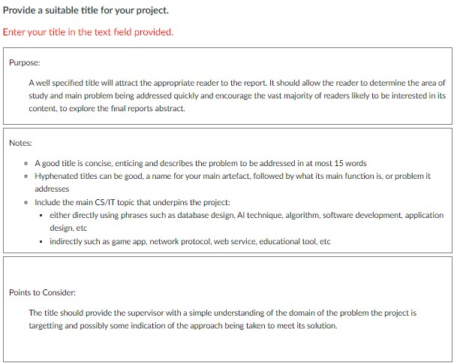

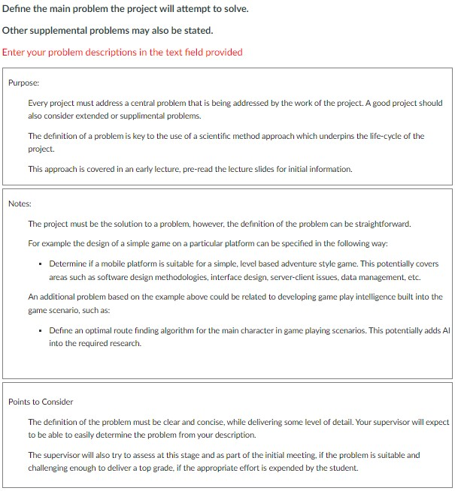

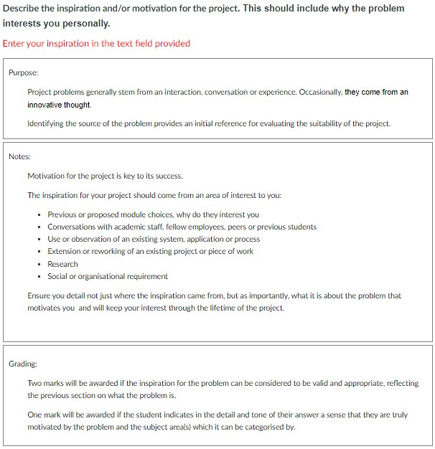

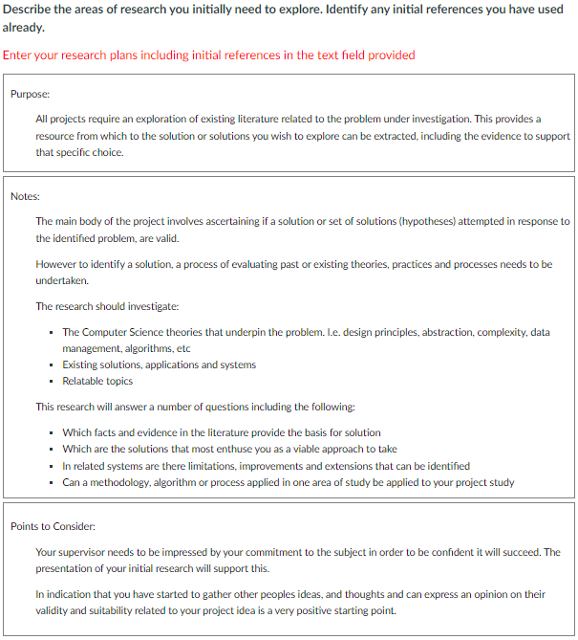

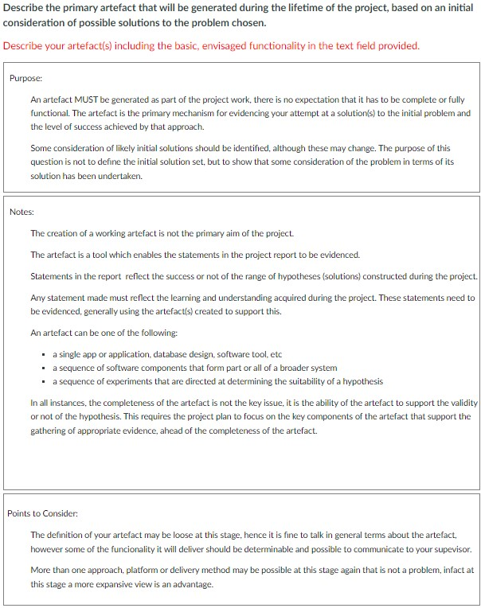
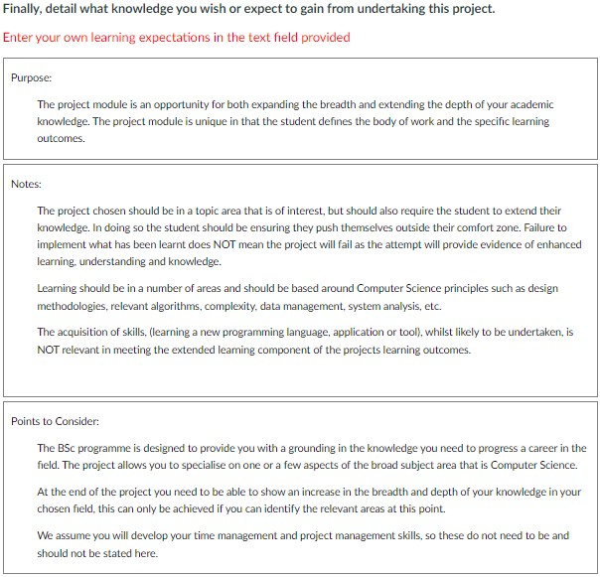

APPENDIX C: Project Resources Checklist
This form must be submitted with the Project Outline, even if NO special requirements are required.
Please PRINT all information CLEARLY
Student’s Name:
SRN:
Project Title:
Supervisor’s Name:
Date:

Please enter your best estimates for the information requested. Changes can be made later.

1 | Will a specialist laboratory PC be required for the project?  If YES, please specify below: | YES | NO
2 | If the answer to 1 is Yes, will you require any special hardware installed/attached?  If YES, please specify below: | YES | NO
3 | Do you require access to specialist systems and/or hardware (Database Servers, Network Hardware, Robotics, etc.)?  If YES, please specify below:
4 | Will you require specific software?  If YES, please specify below: | YES | NO
5 | Are there other resources required, not covered above?  If YES, please specify below: | YES | NO

APPENDIX D: Risk Register
Please enter your best estimates for the information requested. Changes can be made later.
Please PRINT all information CLEARLY
Student’s Name:
SRN:
Project Title:
Supervisor’s Name:
Date:

Please enter your best estimates for the information requested.
In the table below emter
- the task should relate to a sub-task, or a component of a sub-task identified in Section 2
- the identified potential risk associated with this task
- the mitigation to that risk
- The likelyhood of the risk occuring (low, medium, high)
- The severity to the project if the risk occurred (low, medium, high)

Task | Associated Risk | Mitigation | Liklihood | Severity

Add as many rows as needed

APPENDIX E: Ethics Checklist

Ethical Issues
1 | Will your work involve human subjects, e.g., survey, interview, experiment, etc. This includes friends and family. | YES | NO

If the answers to questions 1 is YES, the proposed work must be submitted for approval to the Ethics Committee BEFORE work proceeds. Consult your supervisor and review the UH Ethics Approval Canvas Module for information on the procedures.

APPENDIX F: Project Management Review
Project Management Review (Compulsory inclusion in report)
Student to write not more than two pages discussing the following:

Present the latest version of your Gantt Chart and compare it with the initial project plan.
- What activities demonstrated were critical to the completion of your project?
- What are the main differences between the two Gantt charts?
- What adjustments were needed to ensure the successful completion of the project (if any)?
- Do you think that the estimates made in the initial phase of the project were realistic or optimistic?

Explain and justify the key changes (if any) that affected the project plan.
- What key changes did you make to your project time plan to ensure the timely and successful completion of your project?
- What was/were the reason(s) behind each change?
- What was the impact of such changes on the entire project plan?

Reflect on the strengths and weaknesses of the management of the process.
- What are your strengths and weaknesses as a project manager?
- What aspects of the management of your project are you particularly satisfied with?
- What could have been improved?
- If you were to start the project again, what would you do differently?

Improvements in terms of time management.
- Has your approach to time management changed?
- What has improved in your approach to organising your time?
- Personally, do you find time management a challenge?

APPENDIX G: Calendar 2024-2025
Week  No | Month | Week Beginning | Activity | Schedule/Deadline
9 | Sep | 23 | Ind
10 | Sep | 30 | T | Supervisors Allocated (Wed)
11 | Oct | 7 | T | First Meeting arranged by Student
12 | Oct | 14 | T
13 | Oct | 21 | T | Logbook 1 (Fri)
14 | Oct | 28 | T
15 | Nov | 4 | T | Logbook 2 (Fri)
16 | Nov | 11 | T | Project Outline (Mon)
17 | Nov | 18 | T | Logbook 3 (Fri)
18 | Nov | 25 | T
19 | Dec | 2 | T | Logbook 4 (Fri)
20 | Dec | 9 | T
21 | Dec | 16 | V | Check on Supervisor’s Availability
22 | Dec | 23 | V | Check on Supervisor’s Availability
23 | Dec | 30 | V | Check on Supervisor’s Availability
24 | Jan | 6 | T | Logbook 5 (Fri)
25 | Jan | 13 | EX
26 | Jan | 20 | T | Logbook 6 (Fri)
27 | Jan | 27 | T
28 | Feb | 3 | T | Logbook 7 (Fri)
29 | Feb | 10 | T
30 | Feb | 17 | T | Logbook 8 (Fri)
31 | Feb | 24 | T | Second Markers allocated
32 | Mar | 3 | T | Logbook 9 (Fri)
33 | Mar | 10 | T
34 | Mar | 17 | T | Logbook 10 (Fri)
35 | Mar | 24 | T
36 | Mar | 31 | T | Report (Fri)
37 | Apr | 7 | T | Demo Week
38 | Apr | 14 | V
39 | Apr | 21 | V
40 | Apr | 28 | EX | Alternative Demo Week
41 | May | 5 | EX
42 | May | 12
43 | May | 19
44 | May | 26
45 | Jun | 2
46 | Jun | 9 |  | Results released - Referral Period starts
47 | Jun | 16 | EX
48 | Jun | 23 | EX | Deferral
49 | Jun | 30 |  | Referral *
50 | Jul | 7
51 | Jul | 14
52 | Jul | 21
1 | Jul | 28

Ind – Induction Week
T – Teaching Week
EX – Exam Week
V – Vacation
* Referred students will be given exactly 3 calendar weeks to undertake the referral conditions offered

Compensation is an academic assessment process. If a student’s grade on a module is lower than the pass grade, the Exam Board can compensate this shortfall by supplementing with marks from another module (of the same or higher level) in which the grade achieved by the student exceeds the pass grade by more than that shortfall.
A definition of a non-expert in this case, would be a practicing, professional engineer, or technologist but not someone who is a recognised expert in the specific area of your project.

